69thECCE GENERAL MEETING
31 May – 1June 2019, Podgorica, Montenegro

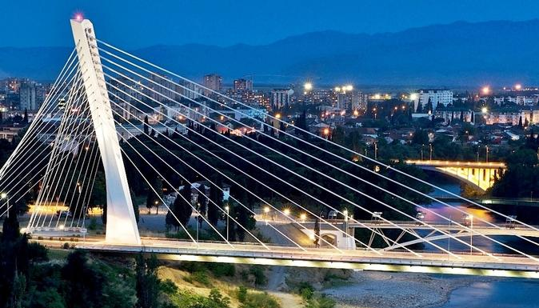

REGISTRATION FORM
Complete this form and return no later than May 15, 2019 to:
Engineers Chamber of Montenegro (Anita Stijepcevic): |  |  |  |  |  |  |  | tel.: +38267885888 |  | E-mail: anita.erak@ikcg.co.me
ECCE Secretary General (Maria Karanasiou): |  |  |  |  |  |  |  | tel.: +306973379151 |  | E-mail: ecce_sps@otenet.gr
PARTICIPANT’S DETAILS
First Name: |  |  |  |  | Family Name:
Phone: |  |  |  |  | Address:
Fax: |  |  |  |  | City, Country:
E-mail: |  |  |  |  | Organization:
FLIGHTS (OPTIONAL)
Arrival: |  | DD/MM/YYYY |  | No. of Flight |  |  | Departure: |  | DD/MM/YYYY |  | No. of Flight
1. FREE REGISTRATION
ExBo Member |  |  | 1stNational Delegate |  |  |  | Invited Association 1st National Delegate
2. PAID REGISTRATION
National Delegate
Name of 2nd Delegate (150 EUR):
Name of 3nd Delegate (150 EUR):
Name of 4nd Delegate (150 EUR):
Name of 5nd Delegate (150 EUR):
Invited Association
Name of 2nd Delegate (150 EUR):
Name of 3nd Delegate (150 EUR):
Name of 4nd Delegate (150 EUR):
Name of 5nd Delegate (150 EUR):
Accompanying person
Name of Accompanying person 1 (150 EUR):
Name of Accompanying person 2 (150 EUR):
3. GUIDED TOURS
GUIDED HALF DAY TOUR FOR ACCOMPANYING PERSONS
Guided half day tour for accompanying persons is prepared on 31 May, 2019 and includes city ​​tour of the museum of King Nikola I Petrovic Njegos, cultural and historical monuments in Cetinje, the national park and the mausoleum of Petar II Petrovic Njegos, lunch, tour guide, transportation and entrance fees. Tour price 40 € - 50 €, depending on the number of persons applied.
Yes |  |  |  |  |  |  | No
GUIDED ALL DAY TOUR FOR ALL DELEGATES AND ACCOMPANYING PERSONS
Guided all day tour for all delegates and accompanying persons is prepared on 1 June, 2019 and includes transportation, lunch, tour guides, tickets and entrance fees. Tour price is included in the registration fee (150 €) and could be refunded. The value of refunds will depend on the number of persons applied.
Yes |  |  |  |  |  |  | No
4. REGISTRATION INCLUDES:
ECCE sessions, meals, coffee breaks, gala dinner and guided all day tour with lunch on 01 June, 2019.
5. HOTEL RESERVATION
Booking Hotel Center Ville is guaranteed no later than 31 March 2019. Registration form is attached.
6. METHOD OF PAYMENT:
Registration fees can be deposited to the account given below or can be paid on arrival in cash (no credit cards).
Beneficiary’s name: Engineers Chamber of Montenegro, Bulevar Dzordza Vasingtona 31, Podgorica, Montenegro
Beneficiary’s bank: NLB Banka
Bank address: Stanka Dragojevica 46, 81 000 Podgorica
IBAN: ME25530005120005027849
S.W.I.F.T.: MNBAMEPG
Details: ECCE 69 GM (paid registration, accompanying person, etc.)
PLEASE SEND COPY OF BANK TRANSFER WITH THIS REGISTRATION FORM IF YOU CHOOSE THE INTERNATIONAL TRANSFER OPTION!
We are looking forward to meeting in Podgorica!

