67th ECCE GENERAL MEETING
30 May – 2 June 2018, Tallinn, Estonia

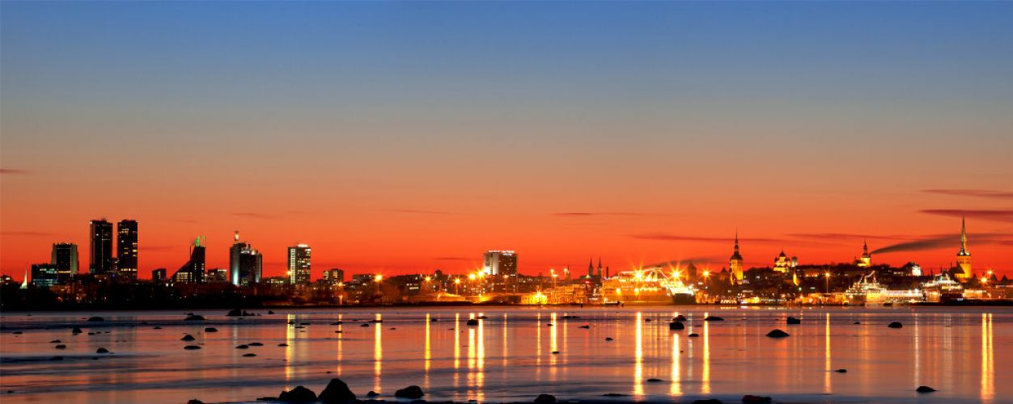

REGISTRATION FORM
Complete this form and return no later than May 9, 2018 to:

Estonian Association of Civil Engineers (Tiia Ruben): tel.: +372 660 4524 E-mail: info@ehitusinsener.ee
ECCE Secretary General (Maria Karanasiou): tel.: +30 6973379151 E-mail: ecce_sps@otenet.gr

PARTICIPANT’S DETAILS
Family Name: First Name:
Organization: Address: City, Country:
Phone: Fax: E-mail:
FLIGHTS (OPTIONAL)
Arrival :(DD/MM/YYYY)………………… No. of Flight Departure: (DD/MM/YYYY).......................... No. of Flight

1. FREE REGISTRATION

ExBo Member 1st National Delegate Invited Association 1st National Delegate

2. PAID REGISTRATION
2nd Delegate (120 EUR) name:………………………………………………………………………..
3rd Delegate (120 EUR) name:………………………………………………………………………..
4th Delegate (120 EUR) name:………………………………………………………………………..
5th Delegate (120 EUR) name:………………………………………………………………………..
Invited Association:
2nd Delegate (120 EUR) name:………………………………………………………………………..
3rd Delegate (120 EUR) name:………………………………………………………………………..
4th Delegate (120 EUR) name:………………………………………………………………………..
5th Delegate (120 EUR) name:………………………………………………………………………..
Accompanying person 1 (120 EUR) name:………………………………………………………………….
Accompanying person 2 (120 EUR) name:………………………………………………………………….

3. PARTICIPATION IN THE INTERNATIONAL CONFERENCE, 1 JUNE

Yes No

Cocktail reception after the conference,

Yes No

4. SIGHTSEEING TOUR TO LAHEMAA NATIONAL PARK FOR ACCOMPANYING PERSON

Yes No

TOTAL…………………..EUROS

REGISTRATION INCLUDES:
ECCE sessions, participation in the conference (1 June 2018), meals, coffee breaks, gala dinner and bus tour on Saturday afternoon;
TOUR FOR ACCOMPANYING PERSONS-Sightseeing tour to Lahemaa National Park, 31 May, 9:30:16:00

METHOD OF PAYMENT:
Registration fees can be deposited to the account given below or can be paid on arrival in cash (no credit cards)

Beneficiary’s name: EESTI EHITUSINSENERIDE LIIT MTÜ
Beneficiary’s bank: Swedbank AS
Bank address: Liivalaia 8, 15040 Tallinn, Estonia
IBAN: EE422200001120045148
S.W.I.F.T.: HABAEE2X
Details: ECCE 67 GM (paid registration, accompanying person etc)

PLEASE SEND COPY OF BANK TRANSFER WITH THIS REGISTRATION FORM IF YOU COOSE THE INTERNATIONAL TRANSFER OPTION

We are looking forward to meeting in Tallinn

